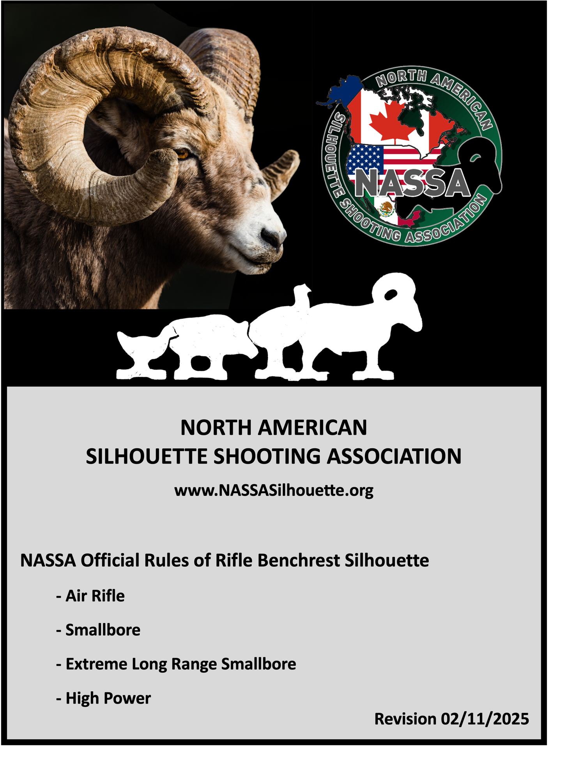
RIFLE BENCHREST SILHOUETTE
North American Silhouette Shooting Association Official Rules of Rifle Benchrest Silhouette
Rifle Benchrest Silhouette is organized, sanctioned, and governed by the North American Silhouette Shooting Association (NASSA).
- General
  - Rules - The local sponsor of competition must agree to conduct the authorized competition according to NASSA rules.
  - Refusal or Withdrawal of NASSA Authorization - NASSA may refuse to authorize or may withdraw its authorization for any competition which cannot, or does not, comply with these requirements.
  - Concordance with Standing Silhouette – Benchrest silhouette is to be conducted along with, on the same range as, and under the same commands as a general standing silhouette match. Benchrest silhouette is not to be conducted as a stand-alone match.
    - Scoring – Benchrest Silhouette should be included on the general scoreboard as its own class. Benchrest Silhouette may be divided into subclasses as described below if participation allows.
      - Subclasses – The match director may divide competitors into subclasses based upon skill classification and/or firing position and/or rifle type.
  - Classification – Rifle Benchrest Competitors may be divided into classifications upon decision of the match director. Classification is established and adjusted in accordance with NRA Rifle Silhouette Rules 19.1 – 19.17.1. Competitors are responsible for accurately keeping record of classification. If a competitor does not know his/her classification, he/she will be unclassified and compete in Master Class.
    - Classification Scores - Individual classification scores based upon a 40-shot match are:
Master...35 to 40
AAA.....29 to 34
AA........22 to 28
A...........15 to 21
B............0 to 14
  - Certification of Rifles -- Rifles must be certified before being fired in a match in whichever manner that the match director sees fit. The rifle must be fired in the same configuration as when certified. No one may win an award with an uncertified rifle. Loads that damage targets may be disqualified by the Match Director, Range Officer or Jury. In case of a malfunction certified by the Range Officer or Jury, a replacement rifle must be certified.
  - Spotters – Spotters are prohibited and competitors should not share information regarding conditions or best practices while on the firing line.
  - Sights - Any sights, telescopic or metallic, may be used. Any sighting device programmed to activate the firing mechanism is prohibited. Any sighting device with rangefinding ability, electronic sight-adjusting ability, or wind-reading ability is prohibited. Illuminated reticles are allowed.
  - Gloves – Gloves are regulated in accordance with NRA Rifle Silhouette Rule 3.11.
  - Clothing – Clothing is regulated in accordance with NRA Rifle Silhouette Rule 3.12.
  - Slings – Slings are prohibited and must be removed before firing a shot for score.
  - Release Triggers – Release Triggers are regulated in accordance with NRA Rifle Silhouette Rule 3.16.
  - Compensators and Muzzle Brakes - Compensators and Muzzle Brakes are regulated in accordance with NRA Rifle Silhouette Rule 3.16.1.
  - Range Flags – Personal range flags are allowed and may be set by competitors at any time that the range is cold and safe.
  - Wind Reading Devices – Any devices designed to read wind, other than downrange range flags, are prohibited.
  - Courses of Fire – Rifle Benchrest Silhouette courses of fire should match the course of fire of the accompanying standing silhouette match(es).
  - Time Allowance and Commands – Rifle Benchrest Silhouette time allowances and commands should match the course of fire of the accompanying standing silhouette match(es).
  - Sighting Shots - Sighting shots are not allowed as a part of the course of fire. This does not prohibit designated practice time provided all competitors have equal opportunity to use such time.
  - Competition Regulations – General competition regulations, including handling of defective cartridges, disabled rifles, protests, and competitor discipline, etc., shall be handled under the rules/program of, and in accordance with, the accompanying standing silhouette match(es).
  - Decision of Ties – Ties are decided by shootoff or reverse animal count in accordance with the rules or program of the accompanying standing silhouette match(es). All shootoffs are made at the turkey target.
- Targets – It is recommended that full-scale, 1/2-scale, & 1/5-scale targets follow the recommended target thickness from the NRA Rifle Silhouette Rulebook. All 1/10-scale targets are recommended to be at least 1/4-inch thick. Air Rifle Benchrest Silhouette targets are recommended to be 3/8-inch thick. Hinged, remotely resettable targets are allowed.
  - High Power Rifle Benchrest Silhouette – All targets are set at 500 meters or yards.
    - Chickens – full-scale
    - Pigs – 1/2-scale
    - Turkeys – 1/2-scale
    - Rams – 1/2-scale
  - Smallbore Rifle Benchrest Silhouette – All targets are set at 100 meters or yards.
    - Chickens – 1/5-scale
    - Pigs – 1/10-scale
    - Turkeys – 1/10-scale
    - Rams – 1/10-scale
  - Air Rifle Benchrest Silhouette – All targets are set at 50 yards.
    - Chickens – 1/10-scale
    - Pigs – 1/10-scale CHICKEN
    - Turkeys – 1/10-scale CHICKEN
    - Rams – 1/10-scale CHICKEN
  - Extreme Long Range Smallbore Rifle Benchrest Silhouette – All targets are set at 200 meters or yards.
    - Chickens – 1/2-scale
    - Pigs – 1/5-scale
    - Turkeys – 1/5-scale
    - Rams – 1/5-scale

- Positions
  - High Power, Smallbore, and Air Rifle Benchrest Silhouette – Competitors may fire from any position: benched, prone, standing, etc.
    - Front Support – A front rest is allowed. The rifle must not be placed on the front rest in such a fashion as to allow the rifle to balance on the rest. The rifle may not be locked into the front rest (bipods attached to the rifle are allowed).
    - Rear Support – The rear of the rifle must be supported by the competitor’s shoulder and shooting hand. No part of the rifle may contact the bench or ground. The shooter’s elbows, forearms, and chest may contact the bench or ground.
      - Non-shooting hand - The non-shooting hand may not support the rifle in any way. The non-shooting hand may not contact the rifle on or behind the trigger guard. The non-shooting hand may not come into contact with both the rifle and the bench, ground, or artificial support at any point rear of the front rest or touch the shooting arm.
      - Artificial Rear Support – Artificial support at any point rear of the front rest is prohibited.
  - Extreme Long Range Smallbore Rifle Benchrest Silhouette – Competitors may fire from any position, benched, prone, standing, etc.
    - Front Support – A front rest is allowed. The rifle must not be placed on the front rest in such a fashion as to allow the rifle to balance on the rest. The rifle may not be locked into the front rest (bipods attached to the rifle are allowed).
    - Rear Support – The rifle may be fully benched. The rear of the rifle may be supported by the non-shooting hand or an artificial support.
  - Physically Disabled Shooters – Every effort shall be made to accommodate any competitor unable to comply with these rules because of a physical disability. Such efforts shall be made as early as possible before the start of the match and should be in accordance with the competitor’s preparation, if possible, to avoid requiring the competitor to use a method of shooting to which he/she is unaccustomed. Such accommodation shall allow the competitor to compete in the general scoring if possible.
    - Protests – Accommodations made by the match director to allow physically disabled shooters to participate are final and are not subject to protest.

- Equipment
  - Rifles and Cartridges
    - High Power Rifle Benchrest Silhouette – Any centerfire rifle with a safe trigger (not subject to accidental discharge) is allowed.
      - Belted Cartridges - Belted Cartridges are prohibited.
      - Magnum Cartridges – Magnum Cartridges are prohibited.
      - Target Damage - Cartridges that the match director deems damaging to targets will be disqualified.
        - Protests – Decisions to disqualify a cartridge due to target damage are final and are not subject to protest.
    - Smallbore Rifle Benchrest Silhouette – Any rifle chambered in .22 short, long, or long rifle with a safe trigger (not subject to accidental discharge) is allowed.
      - Hot Loads - Hot loads, such as “Stingers”, are prohibited.
    - Air Rifle Benchrest Silhouette – Any air rifle, .22 caliber or smaller, 20 FPE or less, with a safe trigger (not subject to accidental discharge) is allowed.
    - Extreme Long Range Smallbore Rifle Benchrest Silhouette – Any rifle chambered in .22 short, long, or long rifle with a safe trigger (not subject to accidental discharge) is allowed.
      - Hot Loads - Hot loads, such as “Stingers”, are prohibited.
  - Rests
    - High Power, Smallbore, and Air Rifle Benchrest Silhouette – Front rests and bipods are allowed.
      - Mechanical Rests – Rests that have the ability to mechanically adjust the point of aim are prohibited. Such rests may be used, but the mechanical adjustability must be disabled or oriented in such a way that it cannot be used by the competitor.
      - Locking Rests – Rests that lock the rifle into place or clamp to the rifle are prohibited. Such rests may be used, but the locking/clamping mechanism must not be used.
        - Bipods – This rule is not to be construed to prohibit bipods, including bipods that attach to the rifle.
      - Rear Rests – All artificial support rear of the front rest is prohibited.

    - Extreme Long Range Smallbore Rifle Benchrest Silhouette – Front rests, bipods, and rear rests are allowed.
      - Mechanical Rests – Rests that have the ability to mechanically adjust the point of aim are prohibited. Such rests may be used, but the mechanical adjustability must be disabled or oriented in such a way that it cannot be used by the competitor.
      - Locking Rests – Rests that lock the rifle into place or clamp to the rifle are prohibited. Such rests may be used, but the locking/clamping mechanism must not be used.
        - Bipods – This rule is not to be construed to prohibit bipods, including bipods that attach to the rifle.

